User Manual:
Welcome the database system for Allegro Music Store (or AMS). This system has three major components that complete a variety of transactions. In this user manual we will walk you through them.
The database is designed for three distinct types of users. Customers who are accessing the music store online, in-store clerks who process in-store transactions and managers who generate reports and manage things that affect both the online and regular store.
You can change between the views by clicking on “File” on the top left-hand corner of the application.
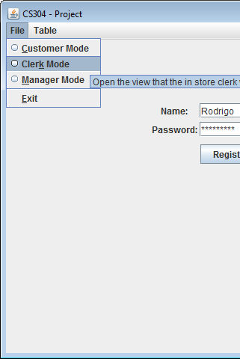
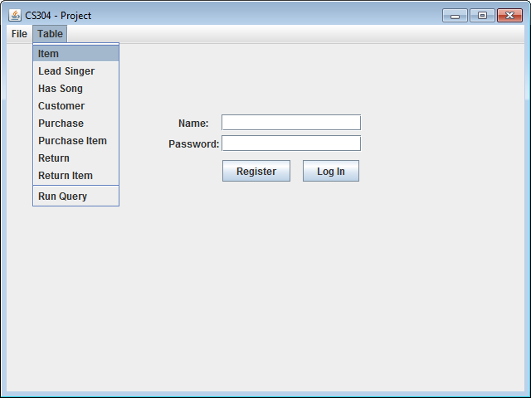
You can also view all the tables within the database through the Table menu. There is also a special feature that allows you to directly run queries on the database—the “Run Query” option.

Customer Mode:
The main operation in the customer mode is to allow the completion of an online purchase. (This is the default view)
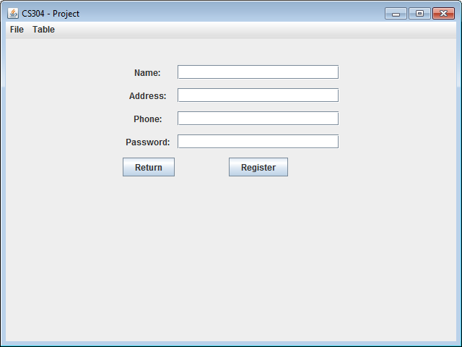
Registration:
Customers who access the store online for the first time have to register first by clicking on the “Register” button. The system will ask for the user's name, address, phone number and password. The address and phone fields are optional but the name and password are needed in order to add the customer to the database. (Internally, the system assigns a unique customer id for the customer). Customer may choose to go back to the log in page by clicking “Return”.
(See updated Customer table)
The user’s name and password must be unique for each customer so therefore if the user name and password selected already exists in the system, the customer will be asked to pick new values by a pop up message and are redirected back to the registration page.
Once the system accepts the values, it will let the user know and will redirect the user back to the login page.
Purchase of an Online Item:
Login
Once registration is completed for the user, they are re-directed back to the main login page where they are asked to enter their name and password and press “Log In”. Once these match the values of an existing customer, they are admitted into the system.
Main Customer View
After the user is logged in, the screen is updated to the user's account containing their shopping cart. If this is the first time the user has accessed the page, then the cart will be empty. Whereas if this were a return visit, then the most recent unprocessed cart will be shown.
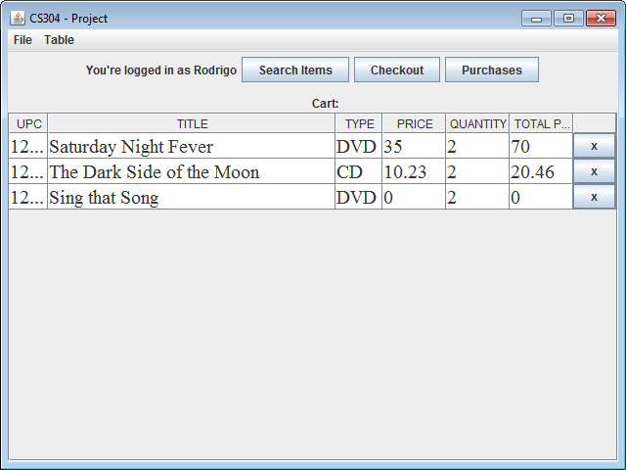
Search:
From the Main Customer View, customers can press the “Search Items” button to look for items. This will change the view to one where customers can describe the item by providing the category, or the title, or the leading singer (or all of them).
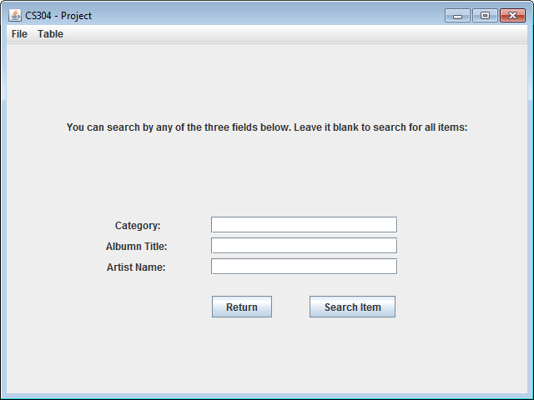

If there are no inputs, then the system outputs a new window with a table of all the items. Otherwise a new window with a table is generated, featuring all the items which fit the search refinements. For each search made, a new window with the results will show up with the current stock at the time of search.
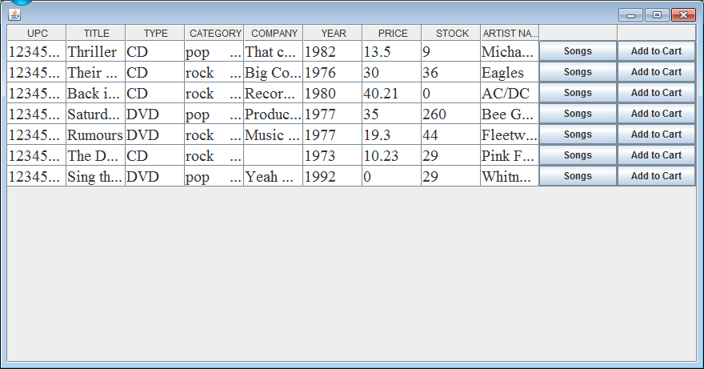
Songs:
Users can find out what songs are included in the item by clicking on “Songs” from the search table. This will generate a new window with a list of song titles for the item.
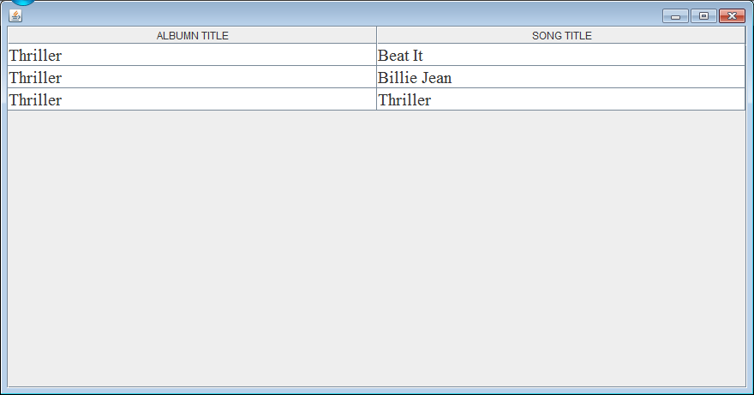

Adding Items to Cart
Based on the items returned in the search results, customers can add items to their cart by pressing “Add to Cart”. This will prompt a pop up window which asks the customer the quantity they would like to add.
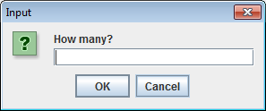
If the item is in stock, then a success message will show up and the customer's last search table will be shown.
If there are not enough stock to meet the quantity demanded, then the system will pop up with a message displaying the discrepancy between the amount requested and the amount in store. It will then give the customer an option to add the existing stock quantity to their cart (if there are any). It then returns back to the last search table where customers can continue to add more items.
Cart
From the search screen, customers need to press “return” to move back to the main customer view which includes the cart. This should show an updated cart. If items are not up to date, move to a different screen, then back to the main screen. Customers can add or remove items from their cart.
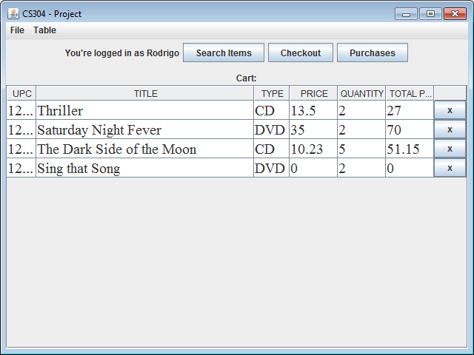

Checkout
When the customer is satisfied with the items in their cart, they can press “checkout” found in the main customer view.
If there is adequate stock in the store to fulfill the cart order, the screen will update to indicate the total number of items and its total price of the cart. Customers are then asked to provide their credit card number and an expiry date. Press “buy” to complete the transaction.
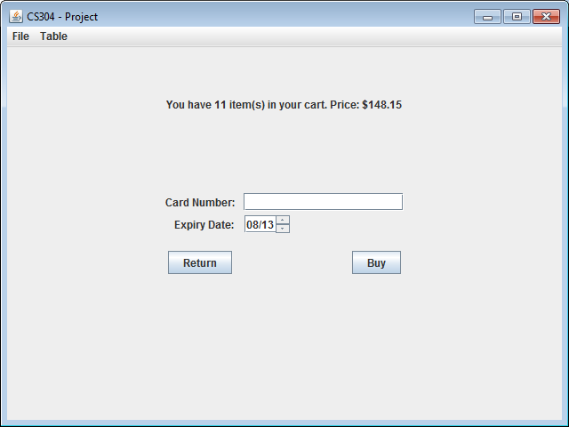

A pop up window will summarize the transaction and customers can complete the purchase by choosing “yes.” If they choose “no” or “cancel”, they will return to the checkout screen.
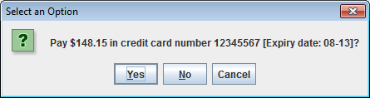

After choosing “yes” to complete the purchase, a screen will pop up indicating that the transaction was successful and how long the order will take to arrive based on the warehouse orders restrictions.
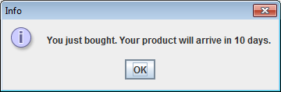

(See updated Purchase and Purchase Item tables.)
Purchase Record
From the main screen, the customer can click on “Purchases” to see a record of their past purchases, including the expected delivery date of every order and the items ordered.
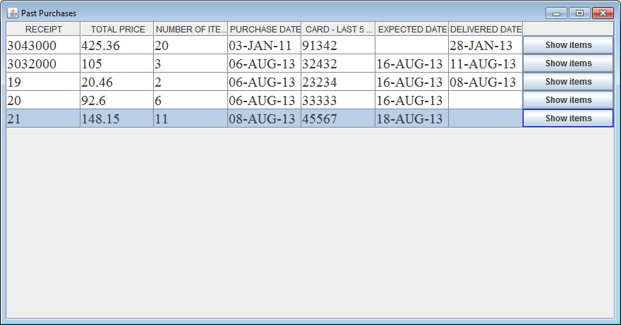

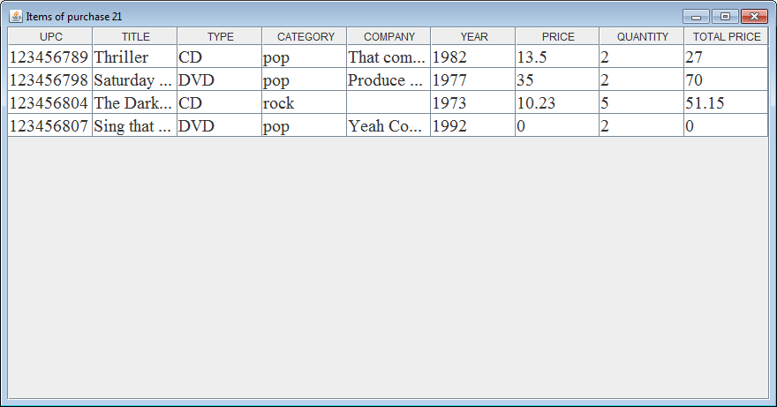
Clerk
The clerk mode can be accessed by clicking on “File” in the left-hand corner and selecting “Clerk Mode” from the drop-down menu.
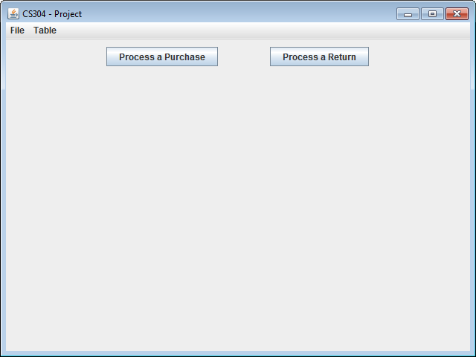
Process the Purchase of in-store items
From the main clerk view, select “Process a Purchase.”
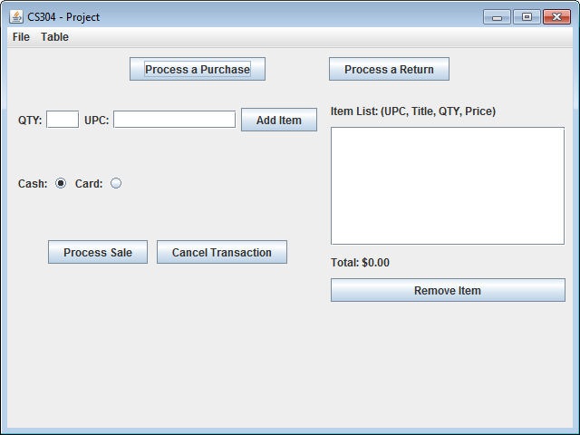

This will take the user to the purchase page and allow the user to enter the item’s upc and quantity in order to make an in-store purchase. After this is provided, the left side of the screen should update with the item listed. More items can be added or removed with the “Add Item” and “Remove Item” buttons.
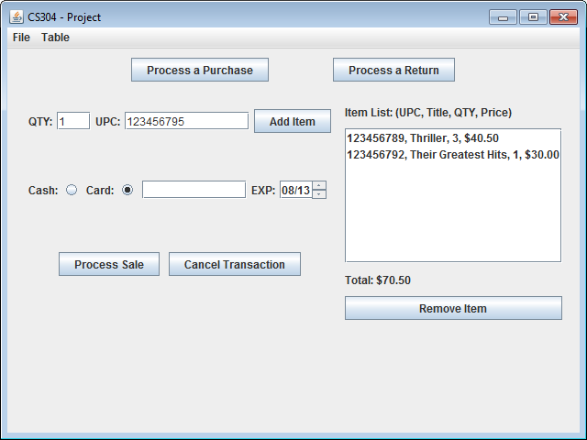
If there are not enough items in the stock to meet the quantity demanded, then the system will pop up with a message displaying the discrepancy between the amount requested and the amount in store. It then returns back to the purchase screen.
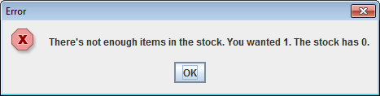

Payment can either be by cash or credit card. If payment is by credit card, then the credit card number and expiry date must be provided before the sale can be processed. The transactions can be aborted by pressing “Cancel Transaction.”
Upon completion of the sale, a Receipt will appear with the details of the transaction.
(See updated Purchase and Purchase Items table)
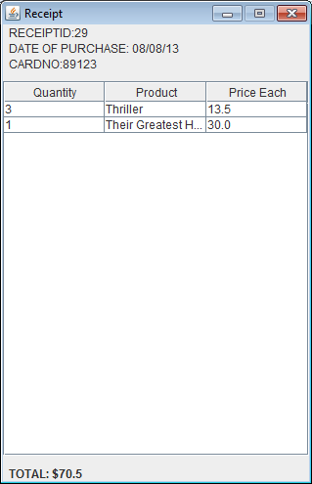
Process the Return of an Item for refund
From the clerk view, select “Process a Return”.
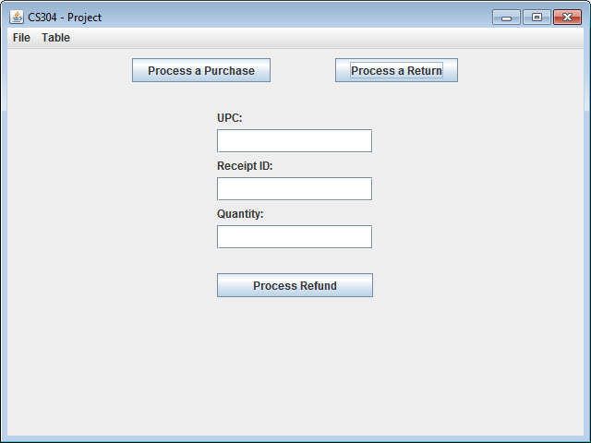

The updated screen will include fields where the clerk can enter the item’s upc, receipt id and quantity in order to complete the transaction.
Proper values must be entered or an error message will appear.
Upon completion, a pop up will show the total return value and the type of payment it made.
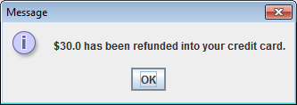

(After it is committed see updated Return, Return Item tables)
Manager
The manager mode can be accessed by clicking on “File” in the left-hand corner and selecting “Manager Mode” from the drop-down menu.
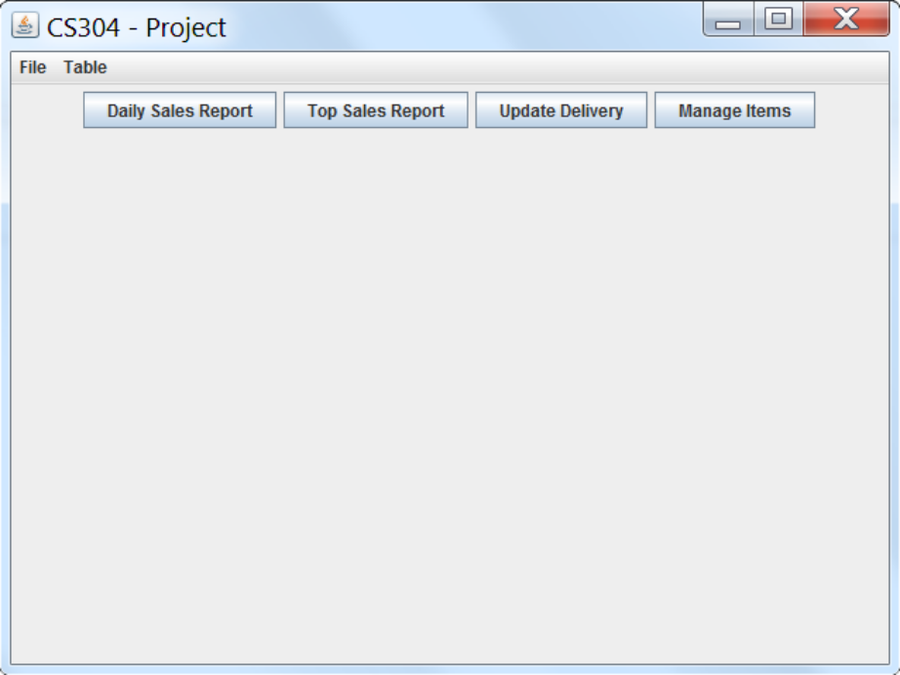
Add items to the store
From the manager view, press “Manage Items”. The display will update to show all the items in the store, and relevant information. It includes a search field where they can look for a specific item by its title.
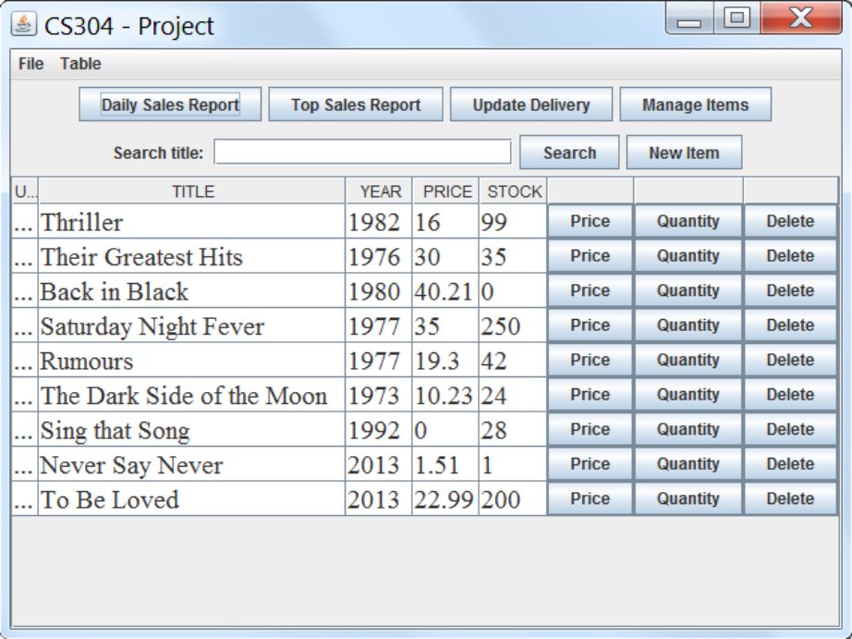

The manager can manually update the stock for an item through the “Quantity” button and update the price by pressing the “Price” button. They can also “Delete” an item from the database (if it is newly added and has no existing relationships with other entries in other tables).

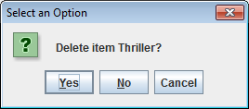
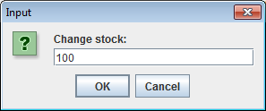

To add a new item to the store, press the “New Item” button. A upc will be automatically generated, but can be changed if needed. The manager must input the item's title, at the very least, in order to insert an item. The item's type, category, record year, price and company information can also be included.
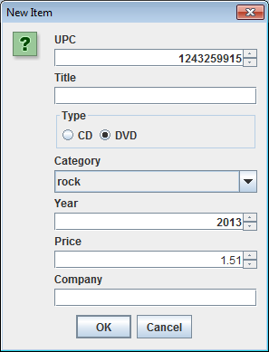

Once a new item is added, the manager must press search again to see the updated item list.
Process the delivery of an order
Press the “Update Delivery” button from the manager view.
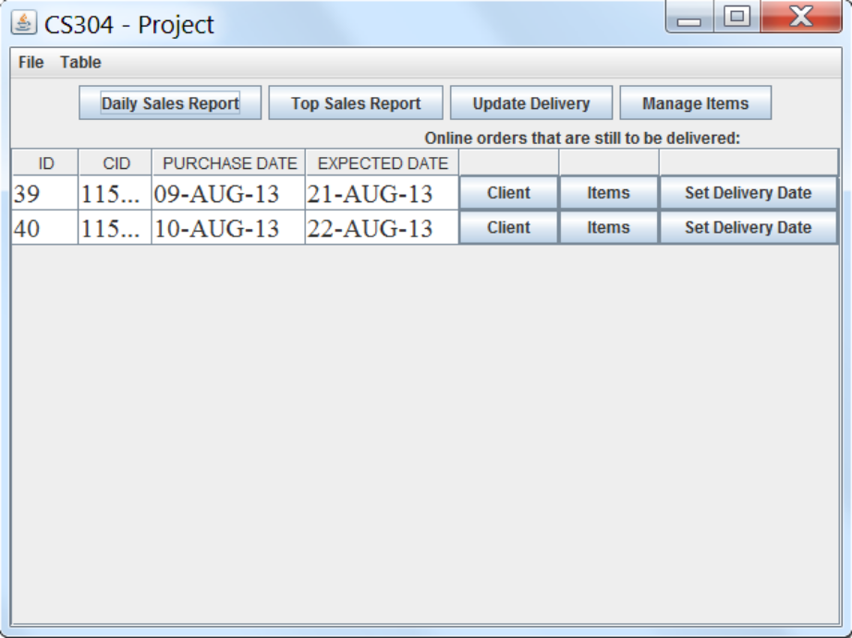

The manager can view information about the orders, the items that were purchased and the customer’s information
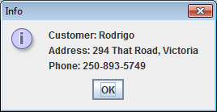

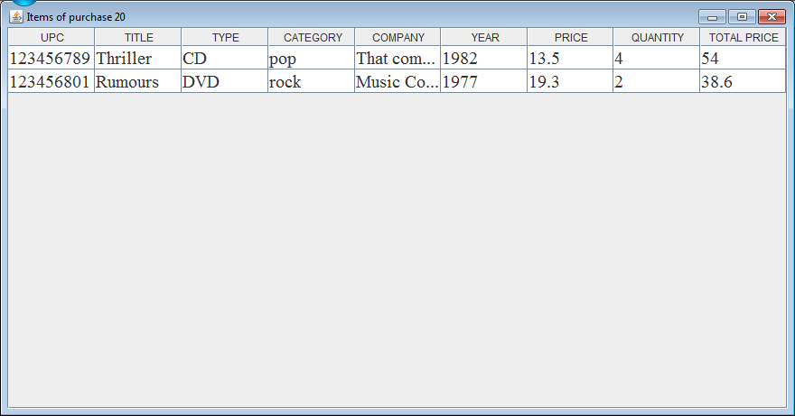

After a delivery date is set, the screen updates that order is removed from the screen.
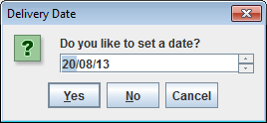

Generate daily sales report
From the manager view, press the “Daily Sales Report” button. The screen will update to for the manager to select a date and then press “Generate Daily Report”.
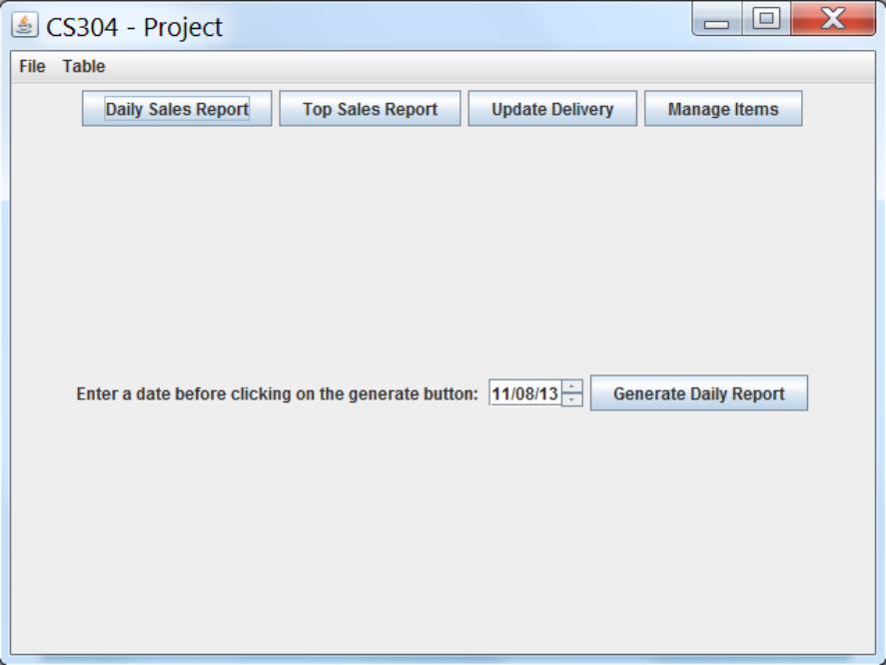
After a date is selected, a report with the results are shown on the screen.
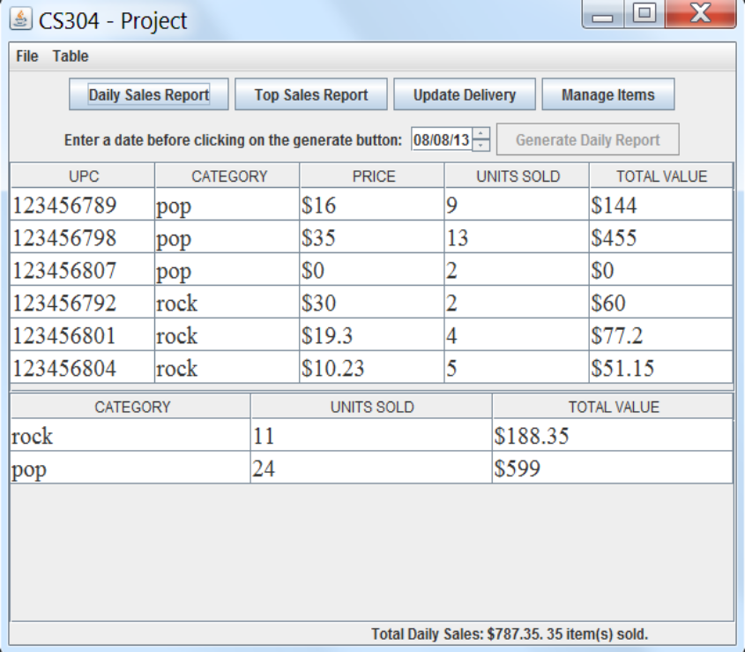

To generate a new report, click on “Daily Sales Report” again.
Generate report on top selling items
From the manger view, press the “Top Sales Report” button. Then indicate the date that the manager wishes to generate the report for and press “Generate Report”.
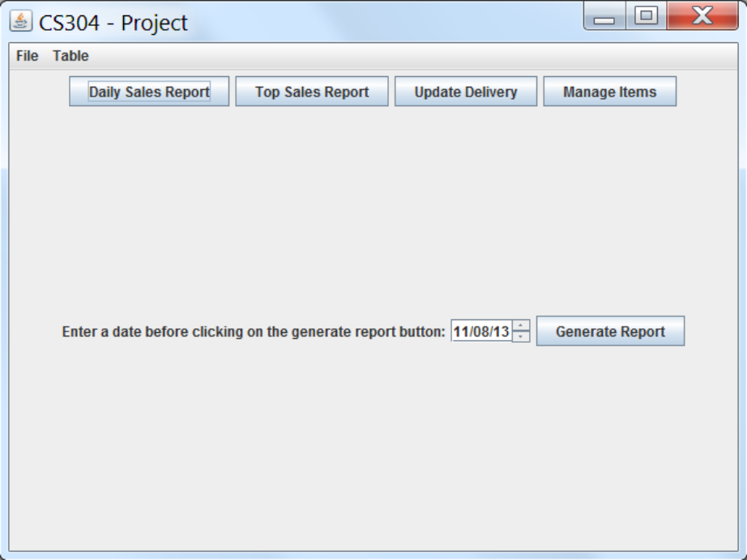
The manager needs to indicate how many items they want ranked. If the number picked exceeds the amount of items in the system, then all the items are ranked and the main screen is updated with the results.
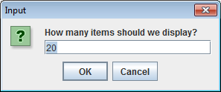

Please look at SQL DOC.pdf for information on our tables and code.
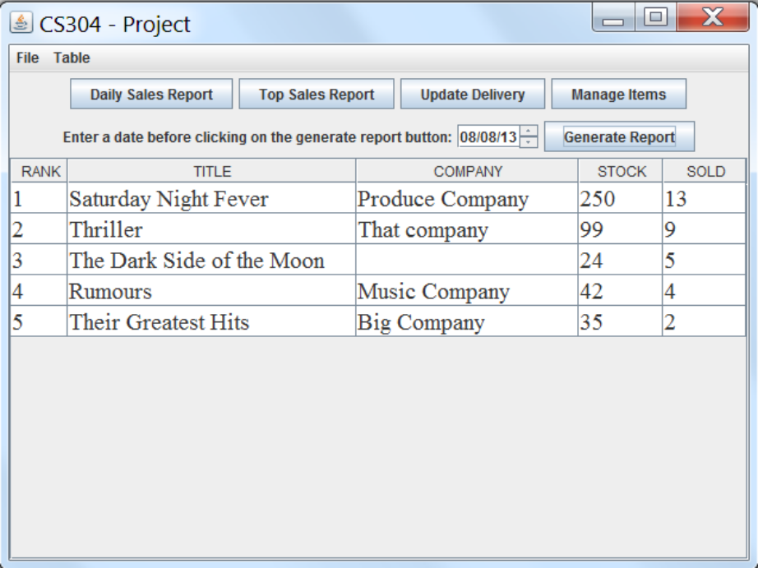

To generate a new report, change the date and click “Generate Report”

